Dear Parent, Athlete or Friend:

Welcome to Special Olympics Kansas! Thank you for taking time to enroll someone you care about in Special Olympics.

Special Olympics is a year-round program of sports training, education, and competition for persons with intellectual disabilities, age eight years and older. The goal of the program is to provide continuing opportunities for the athletes to develop physical fitness, demonstrate courage, experience joy and participate in the sharing of skills and friendship with their families, other athletes and the community.

Enclosed in this Athlete Enrollment Kit is the information and forms you will need to register your athlete for participation in Special Olympics.

Through Special Olympics, athletes gain self-esteem, confidence and discipline, which carry over into other aspects of their lives. For additional information about Special Olympics Kansas, please visit our web site at www.ksso.org.

We look forward to welcoming your athlete into the World of Winners!

Sincerely,
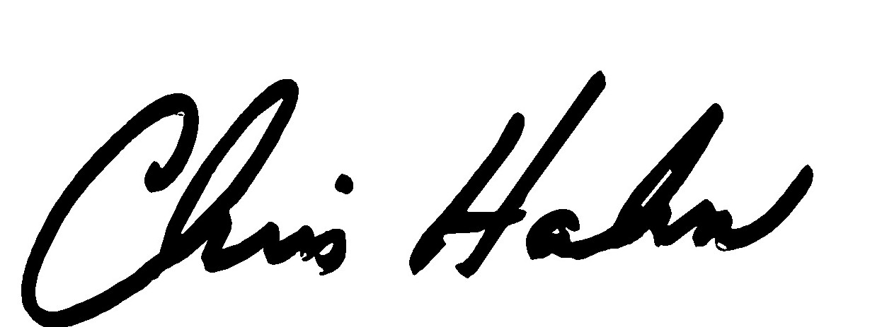

Chris Hahn
President & CEO

Special Olympics Kansas
Athlete Enrollment

Steps to Becoming a registered Special Olympics athlete:

- Complete the enclosed Athlete Information Form.

- Complete the enclosed Special Olympics Kansas Medical Release Form enclosed.
A parent/guardian or adult athlete may sign the release statement.

- Arrange for a physical examination and your athlete’s medical history to be completed. This can be completed by your regular Physician, a Medical Doctor, Doctor of Osteopathy, Doctor of Chiropractic, Physician’s Assistant or Advanced Registered Nurse Practitioner (ARNP). Some Physicians will perform the necessary examination for free or at reduced cost when asked to do so for Special Olympics. Note: If the athlete is Down syndrome, an X-ray must be performed to check for Atlanto-Axial Subluxation. A Down syndrome Addendum is attached, which must also be filled out if appropriate.

- Keep a copy of all the forms for yourself.

- Mail all the completed original forms to the Headquarters Office:

Special Olympics Kansas
5280 Foxridge Drive
Mission, KS 66202

What happens next?

- Each athlete enrollment kit contains a list of Regional Directors, contact numbers, locations and a map of Special Olympics Kansas programs. Once you have reviewed these materials, you may contact the appropriate Regional Director who will then place the athlete on a team according to geographic location.

- Unfortunately, in some cases, no training sites will be convenient. While it is difficult to offer training in every community, we need to know where new athletes would like to see sites added. Where possible, we will work with the community to establish new training programs.

What about competitions?

Special Olympics Inc. rules require a minimum of eight weeks training prior to competition. Special Olympics Kansas offers competition in 21 official sports (team and individual). Some local programs training year-round offers a variety of sports and others offer seasonal training in particular sports. Most local programs train during regular sports session (i.e. track & field in the spring, basketball in the winter).

Athletes are able to compete at local, regional, state and international events. Athletes compete based on ability, age and gender.

Special Olympics Kansas
Athlete Enrollment

Medical Policy

No athlete may participate in an athletic competition or any Special Olympics Kansas event including training, clinics, any activity sponsored by Special Olympics Kansas or any Regional or Local Program, until a completed and signed SOKS Medical/Release Form is on file at the Headquarters office.

Physical Examination Procedure

As noted above, each athlete is required to have an initial SOKS Medical/Release Form on file in the Special Olympics Kansas Headquarters office in Mission, Kansas. The initial SOKS Medical/Release Form includes a physical examination, which must be conducted by a Physician or other professional licensed in the State of Kansas. Licensed professions by the State of Kansas Board of Healing Arts include: Medical Doctor (MD), Doctor of Osteopathy (DO), Doctor of Chiropractic (DC), Advanced Registered Nurse Practitioner (ARNP) or Physician’s Assistant (PA).

Any first time participant in any aspect of Special Olympics Kansas must send in a completed SOKS Medical/Release Form with the physical examination section completed and signed by a licensed professional.

Process:
- Completed SOKS Medical/Release Form is submitted to SOKS
- SOKS Medical/Release Form is checked and if not complete (e.g. missing signatures or dates) forms will be returned
- SOKS will send an email or make a phone call acknowledging receipt of the SOKS Medical/Release Form
- Special Olympics Kansas keeps a record on file
- Coach receives a copy (the coach is responsible for taking their copy to all competition and trainings for their team)

Note: If the athlete is Down syndrome, an x-ray must be performed to check for Atlanto-Axial Subluxation. A Down syndrome Addendum is attached, which also needs to be filled out by a licensed professional if required.

Special Olympics Kansas

Athlete Enrollment

Definition of Eligibility Statement

General Statement of Eligibility. Special Olympics training and competition is open to every person with intellectual disabilities who is at least eight years of age and who registers to participate in Special Olympics.

Age Requirements. There is no maximum age limitation for participation in Special Olympics. Children who are at least six but not yet eight, may participate in age-appropriate Special Olympics training programs or in specific (and age-appropriate) cultural or social activities offered during the course of a Special Olympics event. Such children may be recognized for their participation in this training or other non-competition activity through certificates of participation, or through other types of recognition. However, no child may participate in a Special Olympics competition (or be awarded medals or ribbons associated with competition) before his or her eighth birthday.

Degree of Disability. Participation in Special Olympics training and competition is open to all persons with intellectual disabilities who meet the age requirements, regardless of the level or degree of that person’s disability, and whether or not that person also has other mental or physical disabilities, so long as that person registers to participate in Special Olympics.

Eligibility Criteria. A person is considered to have intellectual disabilities for purposes of determining his or her eligibility to participate in Special Olympics if that person satisfies any one of the following requirements:

(1) The person has been identified by an agency or professional as having intellectual disabilities as determined by their localities; or

(2) The person has a cognitive delay, as determined by standardized measures such as intelligent quotient or “IQ” testing or other measures which are generally accepted within the professional community as being a reliable measurement of the existence of a cognitive delay; or

(3) The person has a closely related developmental disability. A “closely related developmental disability” means having functional limitations in both general learning (such as recreation, work, independent living, self-direction, or self-care). However, persons whose functional limitations are based solely on a physical, behavioral, or emotional disability, or a specific learning or sensory disability, are not eligible to participate as Special Olympics athletes.

Preserving Flexibility in Identifying Eligible Athletes. SOKS may depart from the eligibility requirements identified above if there are exceptional circumstances which warrant such a departure. Any questions related to an athlete’s eligibility on a secondary school team should be referred to the Kansas State High School Activities Association, (785) 273-5329.

Special Olympics Kansas
Athlete Enrollment

Athlete Information Form

Athlete Name: Athlete Age:

Parents/Guardian: _______________________________________________________________
(Person filling out form)

Address:

City/State: Zip Code:

Phone Number: (W) (H)

Email Address:

Location the athlete would like to compete in: Bonner Springs M-410
Please list city or county

Sports the athlete is interested in participating:
____ Aquatics ____ Powerlifting
____ Athletics ____ Roller Skating
____ Basketball ____ Speed Skating
____ Bocce ____ Figure Skating
____ Bowling ____ Alpine Skiing
____ Cheerleading ____ Cross Country Skiing
____ Cycling ____ Soccer
____ Floor Hockey ____ Softball
____ Golf ____ Tennis
____ Gymnastics ____ Unified Sports®
____ Motor Activities Training ____ Volleyball

Please name any sports the athlete is interested in that are not listed:

________________________

Note: Not all sports are offered in every region.

Please fill out the above form and send it to:
Special Olympics Kansas
Athlete Enrollment
5280 Foxridge Drive Mission, Kansas 66202

